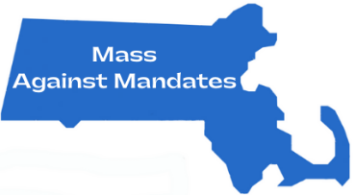

August 2, 2021
By Electronic Mail: [Superintendent Email] cc: [All School Committee Member Emails]
Superintendent Name
Title
[Town] School District
Street Address
Town, MA Zipcode

Re: In-School Face Covering Requirements for [Town] Children

Dear [Superintendent Name] and Members of the School Committee:
We are writing to you as [Town] parents who have children enrolled in the [Town] School District. We are also members of Mass Against Mandates, a grassroots organization comprised of thousands of Massachusetts residents who advocate for medical freedom and the protection of human rights for all. We wish to express our deep concerns regarding the arbitrary mask mandates that have been forced upon our children during the 2020-2021 school year.
For a full year, our children never saw one another's faces. They did not see their teachers’ or their playmates’ faces. They were masked, placed behind plexiglass, and separated from meaningful interaction. Masks were not only mandatory in schools, but in most public and private places. We were told repeatedly by our public health authorities that masks were the key to fighting the pandemic. This notion was repeated every day, so our children complied with it. They had no choice, as very few of their parents questioned it. Some adults who refused to wear masks in public were arrested for it, and that sent the clearest possible message, “Comply or face consequences for not doing what you are told.” So, most people did. However, questions remained. Questions like: Do masks really keep us safe from COVID-19? What is the downside of wearing masks? Why make children wear masks? We have known since the beginning children are not at significant risk from COVID-19, nor are they meaningful vectors for spreading it. As The Lancet put it famously last fall, "COVID-19 is a generally mild disease in children including infants."
More children die in pool drownings every year than have died from COVID-19 so far. According to the latest CDC numbers, just 0.05 percent of all COVID-19 fatalities in the United States have been aged 17 and under. Two research papers published in the medical journal Hospital Pediatrics, found that California pediatric hospitalizations for COVID-19 were overcounted by at least 40 percent, carrying potential implications for nationwide figures. So why have masks been mandated in schools? Well, in part because the teachers unions demanded it, but beyond that, very few people asked such a question.
During the Massachusetts State Legislature Joint Committee on COVID-19 and Emergency Preparedness and Management public hearing held on June 30, 2021, Massachusetts Teachers Association (MTA) President Merrie Najimy shockingly stated, “Please don’t be swayed by anecdotal stories of individual challenges that students are having with the mask. As a whole, they have handled it beautifully and what they’ve learned is that when they take an action, they are protecting their peers and their community.” Obviously, anecdotal opinion and not science is behind such mask policies. Children are easy to command, they do not know any better. Authority figures can make them do anything, and so you did - based on fear, poor science and lack of sound judgment. For over a year, we have asked children to make sacrifices to make adults feel safer. There was no science behind what the powers that be said. They were just guessing and acting like it was settled, but it was not. We know that now because the actual science is finally being revealed. Our juvenile mask policy, the one imposed on the entire country by the teachers unions, education departments and bureaucrats in Washington, D.C. turned out to be a complete disaster. It has been a human tragedy, on a vast scale, and it is living testament to the recklessness of our leaders.
The effects of mask wearing for our children are measurable and have been for some time, but they have been ignored. One large-scale survey of more than 25,000 children conducted in Germany found the overwhelming majority of children reported adverse effects from wearing facemasks, some of them were serious. The effects included excessive CO2 in the bloodstream, profound cognitive impairment, confusion, loss of consciousness, and asphyxiation.
This should be of no surprise, as public health officials knew from the beginning that forcing children to wear masks could be counterproductive. In fact, they knew masks themselves were ineffective and can spread disease because it had been demonstrated by the largest study of the use of medical/cloth masks back in 2015, by researchers in Vietnam. This trial, comparing two-layered cotton cloth masks to medical masks, showed a 13 times higher risk of infection in the cloth masks and concluded, “Penetration of cloth masks by particles was almost 97% and medical masks 44%.” This study suggests cloth masks are not only ineffective, but they may increase the risk of infection, including viral infections such as COVID-19.
Furthermore, researchers conducted a meta-analysis regarding face masks and other nonpharmaceutical interventions and their effects on pandemic influenza in nonhealthcare settings. This study, published in the journal Emerging Infectious Diseases in May 2020 and currently published on the CDC website, concluded:
- “Although mechanistic studies support the potential effect of hand hygiene or face masks, evidence from 14 randomized controlled trials of these measures did not support a substantial effect on transmission of laboratory-confirmed influenza.”
- “In pooled analysis, we found no significant reduction in influenza transmission with the use of face masks.”
- “Disposable medical masks (also known as surgical masks) are loose-fitting devices that were designed to be worn by medical personnel to protect accidental contamination of patient wounds, and to protect the wearer against splashes or sprays of bodily fluids. There is limited evidence for their effectiveness in preventing influenza virus transmission either when worn by the infected person for source control or when worn by uninfected persons to reduce exposure. Our systematic review found no significant effect of face masks on transmission of laboratory-confirmed influenza.”
The size of a Covid-19 particle is between .09 to .12 micron, while the average size of an influenza particle is .12 micron. Therefore, if face masks are not providing a significant effect on transmission of influenza, they are certainly not providing a significant effect on transmission of COVID-19.
In April 2020, an article was published in the New England Journal of Medicine, which concluded:
- “We know that wearing a mask outside health care facilities offers little, if any, protection from infection.”
- “In many cases, the desire for widespread masking is a reflexive reaction to anxiety over the pandemic.”
- “It is also clear that masks serve symbolic roles. Masks are not only tools, they are also talismans that may help increase health care workers’ perceived sense of safety, well-being, and trust in their hospitals. Although such reactions may not be strictly logical, we are all subject to fear and anxiety, especially during times of crisis. One might argue that fear and anxiety are better countered with data and education than with a marginally beneficial mask, particularly in light of the worldwide mask shortage, but it is difficult to get clinicians to hear this message in the heat of the current crisis. Expanded masking protocols’ greatest contribution may be to reduce the transmission of anxiety, over and above whatever role they may play in reducing transmission of Covid-19.”
A September 2020 report by the CDC found that more than 70 percent of COVID-19 positive patients contracted the virus despite faithful mask wearing while in public. Moreover, 14 percent of the patients who said they “often” wore masks were also infected. Meanwhile, just four percent of the COVID-19 positive patients said they “never” wore masks in the 14 days before the onset of their illness.
Stephen E. Petty, P.E., CIH, recently testified as an expert in a Kentucky court case. Mr. Petty has served as an expert witness in approximately 400 cases relating to toxic infectious exposure, personal protective equipment, and as a warning expert. He also served as an epidemiology expert for the plaintiffs in the Monsanto “Roundup” cases, and for those in the Dupont litigation. Mr. Petty holds nine U.S. patents, has written a book comprising nearly 1,000 pages on forensics engineering, is a certified industrial hygienist, and a recognized expert with the Occupational Safety and Health Agency. Mr. Petty helped write the rules on risk assessment for the State of Ohio and has trained Ohio’s risk assessors.
The court’s ruling in this case states:
- Mr. Petty “testified that he has analyzed the use of masks and social distancing in connection with Covid-19. He testified that both the six-foot-distancing rule, and mask mandates, are wholly ineffective at reducing the spread of this virus. Masks are worthless, he explained, because they are not capable of filtering anything as small as Covid-19 aerosols. In addition, masks are not respirators and lack the limited protections that respirators can provide.”
- “According to Mr. Petty, masks have no standards, are not respirators, and do not even qualify as protective equipment. In contrast, respirators have standards, including rules that state respirators may not be worn by persons with facial hair, must be fitted to ensure a seal, and must be timely replaced or, as in higher end respirators, the cartridges must be replaced to prevent saturation. In addition, standards for respirators also require users to obtain a medical clearance because the breathing restriction can impair lung function or cause other problems for persons having such limitations. Putting those persons in a respirator can harm their well-being.”
- “Masks cannot filter the small stuff. According to Petty, because Covid-19 particles are comprised of aerosols, it is really, really, small stuff. Mr. Petty testified that masks leak, do not filter out the small stuff, cannot be sealed, are commonly worn by persons with facial hair, and may be contaminated due to repetitive use and the manner of use. He emphatically stated that mask wearing provides no benefit whatsoever, either to the wearer or others.”
- "Mr. Petty acknowledged that both OSHA and CDC have recommended that people wear masks. However, he called this “at best dishonest.” As an example on this, he pointed to CDC guidance documents where, on page 1, it recommends wearing a mask; but then on page 6, admits that “masks, do not provide . . . a reliable level of protection from . . . smaller airborne particles.” Additionally, one just needs to review CAL OSHA’s October 2020 document titled Safety and Health Guidance, as it states, “Cloth face covers are not protective equipment and do not protect the person wearing a cloth face cover from COVID-19.”
- “According to Mr. Petty, those agencies have smart individuals who know better. Mr. Petty points out that, even before March 2020, it was known that Covid-19 particles are tiny aerosols. And on this, he states that he insisted that fact early on. He also points to a more recent letter by numerous medical researchers, physicians and experts with Ph.Ds., asking the CDC to address the implications of Covid-19 aerosols. Finally, Mr. Petty pointed to another recent study by Ben Sheldon of Stanford University out of Palo Alto. According to that study, ‘both the medical and non-medical face masks are ineffective to block human-to-human transmission of viral and infectious diseases, such as SARS, CoV-2 and COVID-19.”
- “The Court finds the opinions expressed by Mr. Petty firmly established in logic. The inescapable conclusion from his testimony is that ordering masks to stop Covid-19 is like putting up chain-link fencing to keep out mosquitos. The six-foot-distancing requirements fare no better.”
During a public health roundtable held on March 18, 2021 in Tallahassee, FL the following information was shared by top medical professionals:
- Sunetra Gupta, epidemiologist and professor of theoretical epidemiology at Oxford University, stated “In terms of masking children it seems painfully obvious that, that is psychologically, deeply damaging.”
- Dr. Jay Bhattacharya, a professor of medicine at Stanford University and a research associate at the National Bureau of Economics Research stated “I think masks, in some ways, they’ve been harmful because people believe that masks protect them, vulnerable people, and they end up taking more risks than they ought, because they feel like they’re protected by something that does not actually protect them. I think on net, the masks not only have not been effective, but they’ve been harmful.”
- When asked whether children in school should be wearing masks, Dr. Martin Kulldorff, professor of medicine at Harvard Medical School and a biostatistician and epidemiologist at Brigham and Women’s Hospital in Boston stated “Children should not wear face masks, no. They don’t need it for their own protection, and they don’t need it for protecting other people either.”
- Dr. Scott Atlas, Robert Wesson Senior Fellow in health care policy at the Hoover Institution of Stanford University, stated “So there’s no evidence that a mask mandate has worked, and in fact there is evidence as Jay cited, that the people in the United States had a very high frequency of wearing masks for months and the cases exploded.”…“I think the masks in schools, there’s no scientific rational or logic to have children wear masks in schools.”
Additionally, please review the charts below which provide a visual as to what effect mask mandates have had on COVID-19 cases.

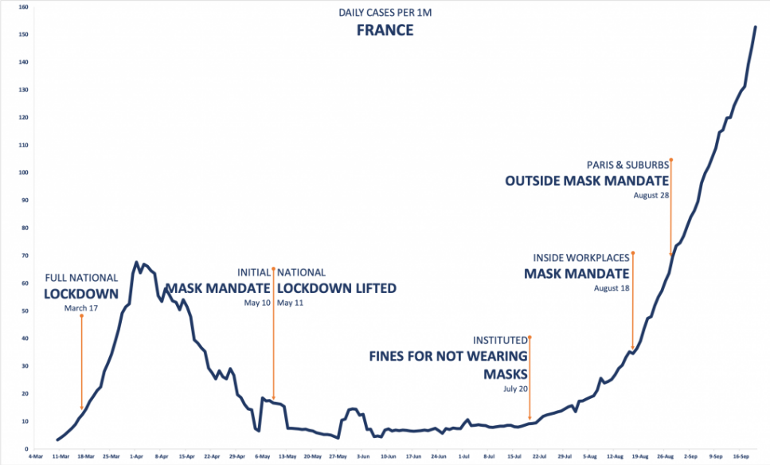
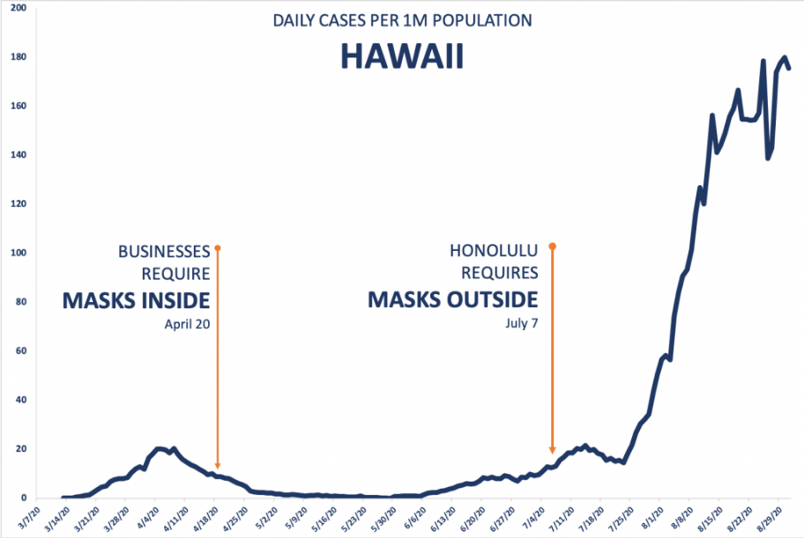
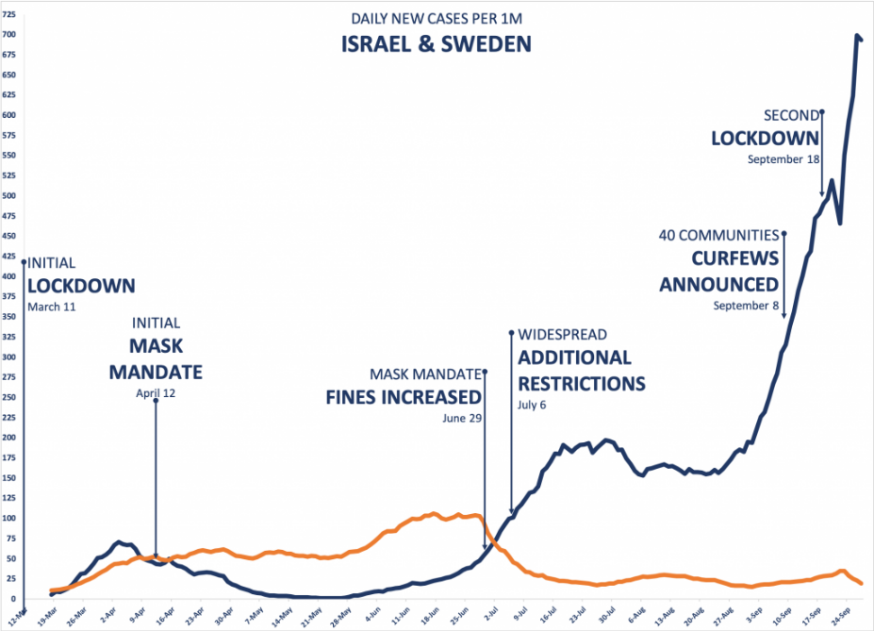

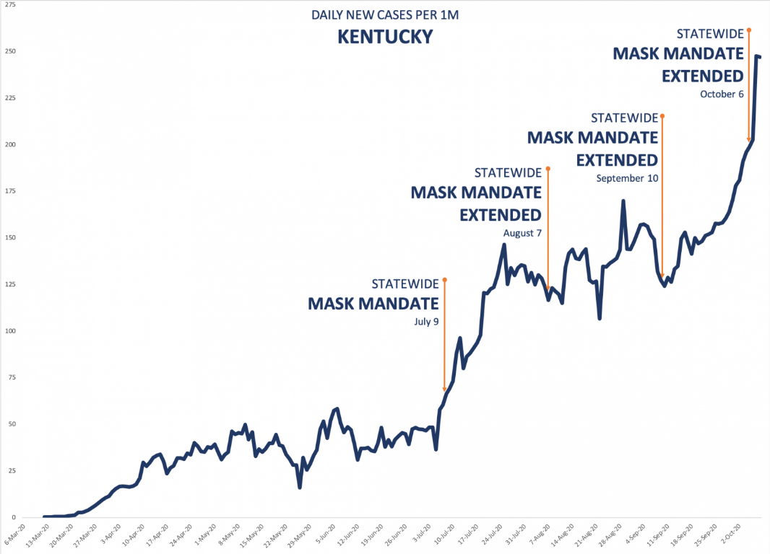
Below is a chart displaying the 25 most stringent lockdown states (red) graphed against the 25 least stringent (blue). There was little difference between the two groups’ hospitalization rates. The trajectory is nearly identical. Both had the same average inpatients per day, 23 per 100,000.
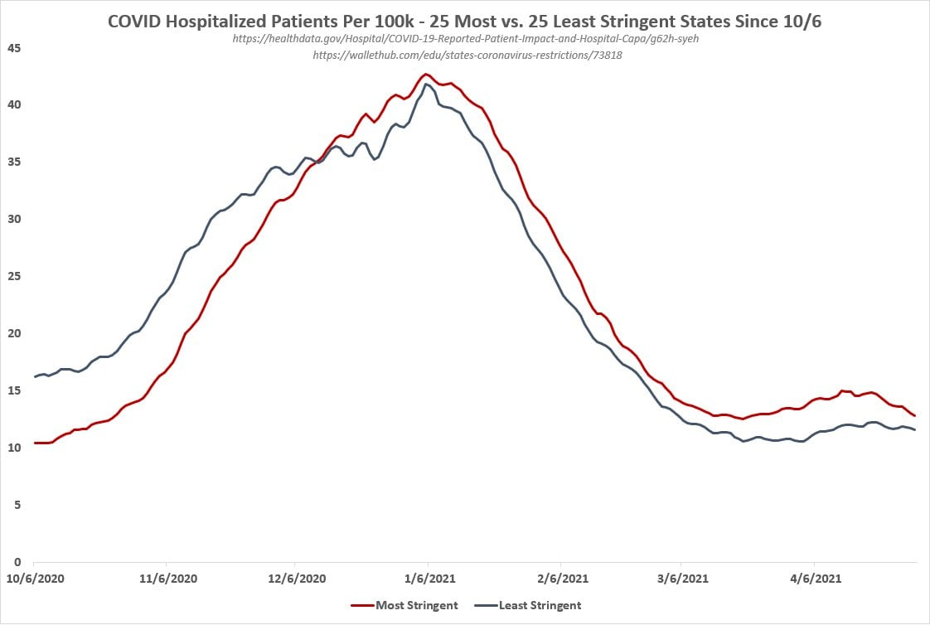
These findings have been available for some time and were known to anyone who cared to check. What we all knew, and we do not need a medical degree to know, is that fresh air is beneficial because people need oxygen, but that simple point was ignored completely by the people in charge, and masks were continued to be mandated for children.
What happened because of such a mandate? Children began to collapse from lack of oxygen, but no care was given. Parents would have to take matters into their own hands, and some did. In June of 2021, parents in Florida sent masks worn by their children in school to the University of Florida’s Mass Spectrometry Research and Education Center to be analyzed for contaminants. The masks studied were new or freshly laundered before they were worn for five to eight hours by children aged 6 through 11. Of the six coverings, three were surgical, two were cotton, and one was a polyester gaiter. Masks that had not been worn and a t-shirt worn at school acted as the control samples for the analysis.
“Five of the masks were found to be contaminated with parasites, fungi, and bacteria. One was found to contain a virus that can cause a fatal systemic disease in cattle and deer. Other, less harmful pathogens that can cause ulcers, acne, and strep throat were also detected on the face coverings. None of the controls were contaminated with pathogens, while “samples from the front top and bottom of the t-shirt found proteins that are commonly found in skin and hair, along with some commonly found in soil.”
On July 8, 2021, New Jersey senators held a hearing to explore whether or not science supports mask mandates for children in school. Dr. Martin Kulldorff, professor of medicine at Harvard Medical School who was mentioned previously in our letter, stated “COVID is primarily spread through adults. When children do get infected … they typically get it from an adult. And it’s very unusual to get transmission from children to adults.” He further explained the risk of COVID-19 infection for teachers is the same or slightly lower than the average in other professions. “There’s no purpose of wearing masks, either for the benefit of the children or for the benefit of teachers. There’s no public health reasons to do that.” Maria Crisler, a clinical scientist with specialty experience in microbiology warned the issue of mask-wearing is even more critical for children than for adults because anatomical differences make a child more vulnerable than an adult to injury from oxygen deprivation and high intake of carbon dioxide. She stated, “There are physiological changes within 45 seconds of wearing a mask to the brain, from the heart, the lungs, the kidneys, and the immune system.” She further explained microbes can concentrate on the outside of masks because microbe carrying droplets are trapped in masks and can be re-inhaled. “Without a mask exhaled droplets and aerosol dry quickly. … The longer the mask is used, the more bacteria are exhaled through it. The outside of surgical masks, the ones that the children are mostly wearing to school, tested in hospitals, found more concentrated microbes on the outside of the masks themselves than in the environment.”
Public Health England has emphatically stated they do not recommend face coverings for children under the age of eleven. Their strong consensus is that COVID-19 infection rates are very low among this age group, and that face masks affect children’s development.
Looking back at the unnecessary masking requirements, it is clear, with research in hand, these findings will expose a growing scandal. Those in charge may someday be held accountable for their actions in this matter. Despite the plethora of evidence that exists regarding the ineffectiveness and actual harm mask mandates cause for our children, they are still being considered for the 2021-2022 school year.
On July 9, 2021, the CDC issued new “guidance” that recommends anyone over the age of 2, who is not vaccinated, wear a mask indoors and schools maintain at least 3 feet of physical distance between students within classrooms. Such requirements are unscientific and unnecessary for more than just the many reasons outlined above. Through a partnership of organizations including The School Superintendents Association, the National Association of Secondary School Principals, the National Association of Elementary School Principals, and Brown University Professor of Economics Emily Oster, the National COVID-19 School Response Dashboard was formed. The National COVID-19 School Response Dashboard systematically maps schools’ responses to the pandemic across the United States to empower school leaders, policymakers, and the general public to make data-driven teaching and learning decisions. Below are three bar charts comparing the student and staff COVID-19 case rates among schools who require masks with schools who do not, within three distinct types of communities. As displayed below, the unmasked students and staff had lower COVID-19 case rates compared to those who were required to be masked, no matter how low or high their community transmission rate was. These findings are consistent with the results from various scientific studies previously referenced.
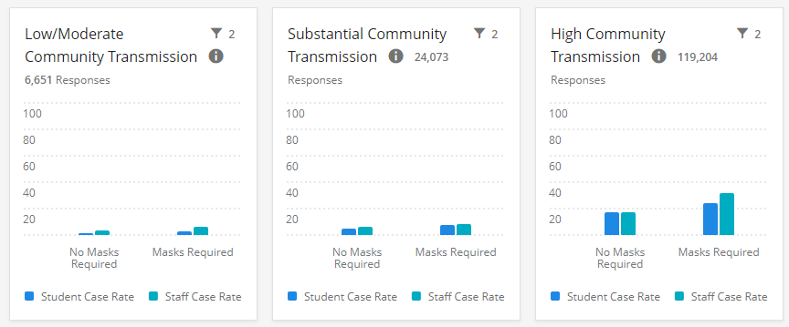

This new guidance published by the CDC is not rooted in science but is unfortunately rooted in politics. Remember, it was the CDC that asked teachers unions to craft language for its school reopening guidelines; guidelines that were not in line with actual scientific evidence. These guidelines unnecessarily kept children out of school and contributed to the skyrocketing cases of mental health issues and lack of educational development across the U.S. It is also abhorrent the lack of a vaccine for young children is being used as a reason why children should be forced to wear masks during school. Children do not need this vaccine, period. In addition to their low infection rates, low transmission rates, presentation of mild symptoms and high recovery rates, in-school transmission rates are low. As the CDC states, “A study comparing COVID-19 hospitalizations between counties with in-person learning and those without in-person learning found no effect of in-person school reopening on COVID-19 hospitalization rates when baseline county hospitalization rates were low or moderate.” To coerce our children by allowing them to breath freely and without harmful side effects caused by masks, in exchange for participation in a clinical trial of an experimental drug is unethical, immoral and repugnant.
According to the latest CDC data and estimating a 97% vaccine efficacy rate, mortality risk for unvaccinated children is lower than vaccinated adults over age 30. The mortality risk for unvaccinated children is 100x lower than vaccinated adults over 75.
The most recent concern stated by teachers unions and others is regarding the Delta variant of COVID-19. The latest data from Public Health England is finding the Delta variant is much less lethal than the Alpha. In its recent report dated July 8, 2021, Public Health England demonstrated Delta variant’s case fatality rate (CFR) is .2%, compared to Alpha’s CFR of 1.9%, and that vaccines help reduce Delta’s CFR in people over the age of 50 but not under.
The state of Massachusetts is ranked as the second highest in the U.S. in terms of adults vaccinated and has the lowest rates of vaccine hesitancy in the country. Every adult in Massachusetts who wants the COVID-19 vaccine has had the opportunity to receive it. “In Israel, a leader in the world in terms of the proportion of adults vaccinated, infection rates in unvaccinated children declined 99% after widespread vaccination of the adults. We have been witnessing the same trend in the U.S. Israel has, therefore, decided to recommend vaccination only for certain high-risk children aged 12 to 15 rather than all of them. Other countries are taking a similar approach because children are simply not the primary drivers of the pandemic. In Massachusetts, our unvaccinated children will be protected from SARS-CoV-2 infection as a direct result of the success of our mass vaccination campaign of adults. This is something to celebrate – and means that life can begin to return to normal for all of us – including kids inside and outside of school.”
Iowa, Texas and Vermont have passed legislation or signed executive orders that forbid school districts from requiring face coverings because they have followed the data and the science, as you should be doing as well. DESE and [Town] School District removed parental choice during the 2020-2021 school year – this was wrong. Parents should always have the authority to make medical decisions for their children, not bureaucrats. This past year has been an extremely eye-opening experience. Throughout this human tragedy, something wonderful has happened. Parents across Massachusetts have come together. We have organized and mobilized by the thousands. We have connected with hundreds of like-minded parents in our immediate areas, and with tens of thousands of others across the state. Due to the failure of our so-called leaders, we have become involved, knowledgeable, and resourceful; and we will never let our children be abused and used as political pawns again. [Superintendent Name] and members of the School Committee, please do not resort to arbitrary, ineffective, emotionally, and physically harmful masking policies again – we will not stand for it. Tens of thousands of parents across Massachusetts are prepared to withdraw their children from public schools and in turn, withdraw the funds as well. Our children’s emotional and physical well-being will always be our number one priority.

In closing, this letter serves as notice that mandates for any individual to wear a mask against COVID-19 for attendance at school violates federal law. All COVID-19 masks, whether surgical, N95 or other respirators, are authorized, not approved or licensed, by the federal government; they are Emergency Use Authorization (EUA) only. Federal law states:
Title 21 U.S.C. § 360bbb-3(e)(1)(A)(ii)(I-III) of the Federal Food, Drug, and Cosmetic Act (FD&C Act) states:
individuals to whom the product is administered are informed -
(I) that the Secretary has authorized the emergency use of the product;
(II) of the significant known and potential benefits and risks of such use, and of the extent to which such benefits and risks are unknown; and
(III) of the option to accept or refuse administration of the product, of the consequences, if any, of refusing administration of the product, and of the alternatives to the product that are available and of their benefits and risks.
EUA products are by definition experimental and thus require the right to refuse. Consent of the individual is “absolutely essential.” A federal court held that even the U.S. military could not mandate EUA vaccines to soldiers. Doe #1 v. Rumsfeld, 297 F.Supp.2d 119 (2003). In a letter dated April 24, 2020, the Food and Drug Administration stated that authorized face masks must be labeled accurately and may not be labeled in a way that misrepresents the product’s intended use as “source control to help prevent the spread of SARS-CoV-2.” The letter specifies the labeling “may not state or imply that the product is intended for antimicrobial or antiviral protection or related uses or is for use such as infection prevention or reduction.” Any EUA mandate requiring individuals to wear face masks conflicts with Section 360bbb-3(e)(1)(A)(ii)(I-III), which provides that the person must be informed of the option to refuse to wear the device. Liability for forced participation in a medical experiment, including possible injury, may be incalculable. You must uphold the rights of individuals to refuse to wear EUA masks.
We understand a school committee meeting is scheduled for mm/dd/21. We are requesting this topic be added to the agenda and a vote by committee members is taken, ensuring masks will be optional for the 2021-2022 school year and beyond. [OR IF NO MEETING IS SCHEDULED ADD THE FOLLOWING LINE INSTEAD] We understand currently there is no school committee meeting scheduled before the start of the 2021-2022 school year. We are requesting a meeting be scheduled as soon as possible so this matter can be discussed and a vote by committee members is taken, ensuring masks will be optional for the 2021-2022 school year and beyond. It is time to put our children and medical facts above politics and fear. Free our children NOW from the medical ignorance and abuse delivered by those who may mean well but who are instead harming children with irresponsible and ineffective policies. Unmask the politics and fear, and unmask our children permanently.
Very truly yours,

https://www.thelancet.com/journals/lanchi/article/PIIS2352-4642(20)30177-2/fulltext
https://www.statista.com/statistics/1191568/reported-deaths-from-covid-by-age-us/
https://nymag.com/intelligencer/2021/05/study-number-of-kids-hospitalized-for-covid-is-overcounted.html?fbclid=IwAR3LWSIjQAjoLOTdP7bd1cvsIIAQJc3pTYS_9zGlkJlGxWbxCmr-Fwxw874
https://www.msn.com/en-us/health/medical/fauci-admits-post-vaccination-masking-was-about-signals-weeks-after-insisting-otherwise/ar-BB1gRQVY
https://www.researchsquare.com/article/rs-124394/v1
https://bmjopen.bmj.com/content/5/4/e006577
https://wwwnc.cdc.gov/eid/article/26/5/19-0994_article
https://www.nejm.org/doi/full/10.1056/NEJMp2006372
https://www.cdc.gov/mmwr/volumes/69/wr/pdfs/mm6936a5-H.pdf
https://www.wkyt.com/2021/06/09/boone-county-judge-orders-permanent-injunction-against-gov-beshears-covid-19-orders/
https://www.dir.ca.gov/dosh/Coronavirus/COVID-19-Infection-Prevention-in-Agriculture.pdf
https://www.wesh.com/article/watch-live-gov-desantis-holds-public-health-roundtable-discussion-in-tallahassee/35874378
https://tomwoods.com/covid/
https://twitter.com/The_OtherET/status/1390368965994631175?s=20&fbclid=IwAR2ul7PXTh_An-oPqNvg8DKHTzt2-VRyABwkzyvzZjdNNCXgg_HzY1sQpqE
https://www.msn.com/en-us/sports/ncaafb/track-coach-blasts-lawmakers-after-athlete-forced-to-wear-mask-collapses-at-finish-line/ar-BB1fZ4Qh
https://www.theepochtimes.com/university-of-florida-lab-finds-dangerous-pathogens-on-childrens-face-masks_3865300.html?utm_source=YouTube&utm_medium=Social&utm_campaign=FactsMatter&utm_term=Bacteria
https://www.theepochtimes.com/mkt_morningbrief/mask-mandate-for-children-is-not-backed-by-science-new-jersey-senators_3903570.html?utm_source=sharemorningbriefnoe&utm_medium=email&utm_campaign=mb-2021-07-18&mktids=294f7d611c2c5f6768ab137ff44dd7b2&fbclid=IwAR3UWScgQgsB6hRhJxMrN82LkXTlJrPE8gLkYAH4LBgsVIoYII_RovJ3tOE
https://www.gov.uk/government/publications/face-coverings-when-to-wear-one-and-how-to-make-your-own/face-coverings-when-to-wear-one-and-how-to-make-your-own
https://www.cdc.gov/coronavirus/2019-ncov/community/schools-childcare/k-12-guidance.html
https://covidschooldashboard.com/
https://www.theepochtimes.com/teachers-union-head-cdc-asked-us-for-language-on-school-reopening-guidelines_3822052.html
https://www.cdc.gov/coronavirus/2019-ncov/science/science-briefs/transmission_k_12_schools.html
https://healthdata.gov/dataset/AH-Provisional-COVID-19-Death-Counts-by-Age-in-Yea/e3ga-ybc7
https://assets.publishing.service.gov.uk/government/uploads/system/uploads/attachment_data/file/1001009/Variants_of_Concern_VOC_Technical_Briefing_18.pdf
https://www.nbcboston.com/news/local/massachusetts-has-lowest-vaccine-hesitancy-rate-in-the-u-s/2362121/
https://www.usnews.com/news/healthiest-communities/articles/2021-07-05/why-massachusetts-schoolchildren-shouldnt-be-required-to-wear-masks
https://history.nih.gov/display/history/Nuremberg+Code
https://www.fda.gov/media/137121/download#:~:text=On%20April%2024%2C%202020%20in%20response%20to%20questions,protect%20the%20public%20health%20or%20safety%20under%20section

